

*shell programming lab*

aSsignment -9

**SUBMITTED BY: SUBMITTED TO:**

**AYUSH KUMAR JHA Dr. Dhiviya Rose**

**SAP ID - 500086400**

**Enrollment no - R200220083**

**B.C.A -I.O.T.**

1. Write the sed command to print the line 3-6 from the input file.

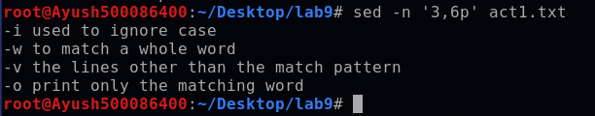

2. Write the sed command to print the lines except the line 3-6 from the input file.

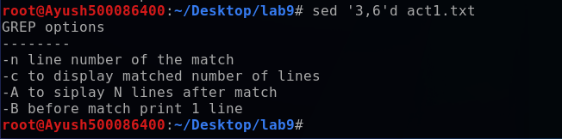

3. Write the sed command to print the lines line 3-6 and 7-9 from the input file.

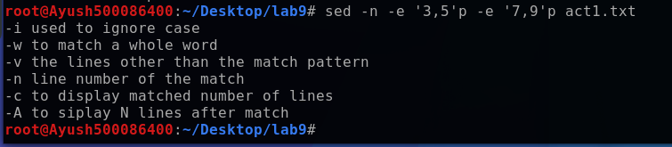

4. Write the command to replace the 'word' with 'text'.

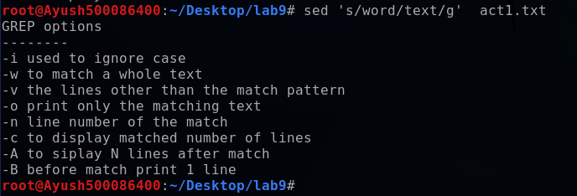

5. Write the command to replace 'text' only within a line range 1-3

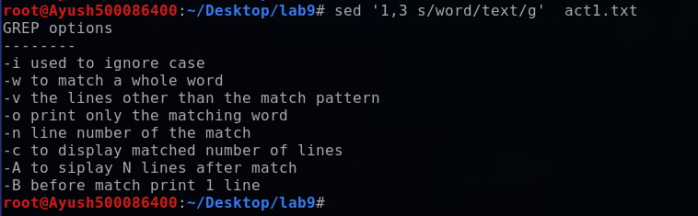

6. Write a sed command to replace multiple blank spaces with a single space.

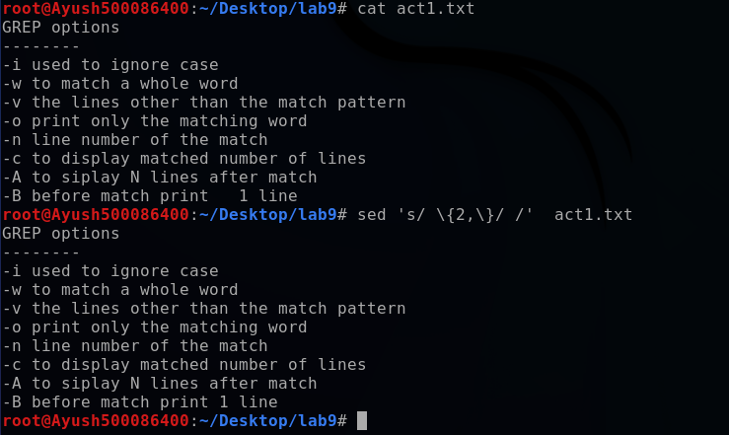

Activity 2:

Consider a file with the content linux is 100 % great os.

a) Write a sed command that print numbers of lines beginning with “u”.



b) Write a sed command that delete digits in the given input file.

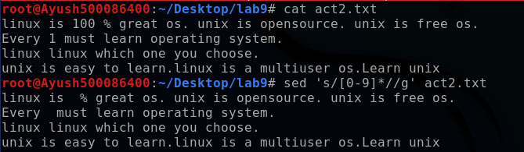

c) Write a sed command that delete lines that contain both unix and linux..

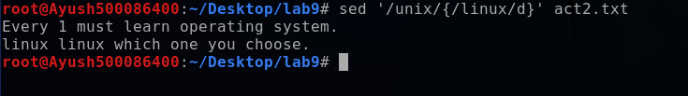

d) Write a sed command that delete lines that contain unix but not linux.

